User Guide

Administrator

1. Main Panel

Form the main panel the user (Administrator) need to click the dispatch icon as listed on the image below.

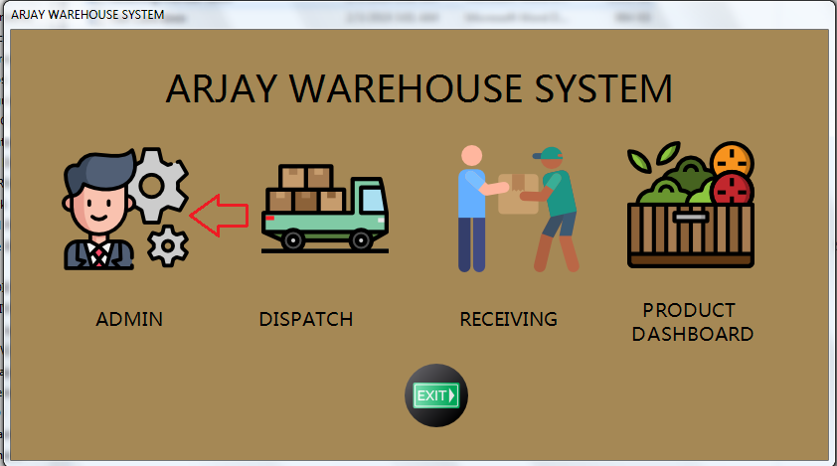

1. Login

After clicking the dispatch icon the dispatch personnel is required to enter the credential given to him/her by co - system administrator.

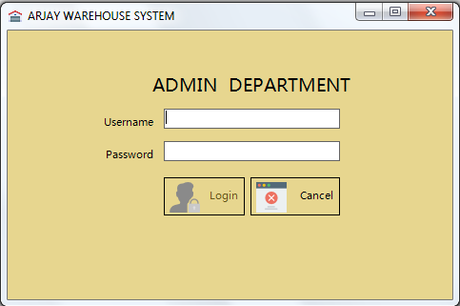

Here is the error message if credential entered is incorrect.

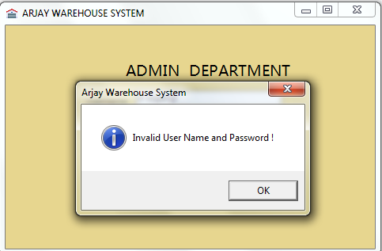

1. Admin Dashboard

After a successful login the Administrator will be redirected to the Admin Dashboard Pane. Here the Administrator can see various option that he can use for production reason.

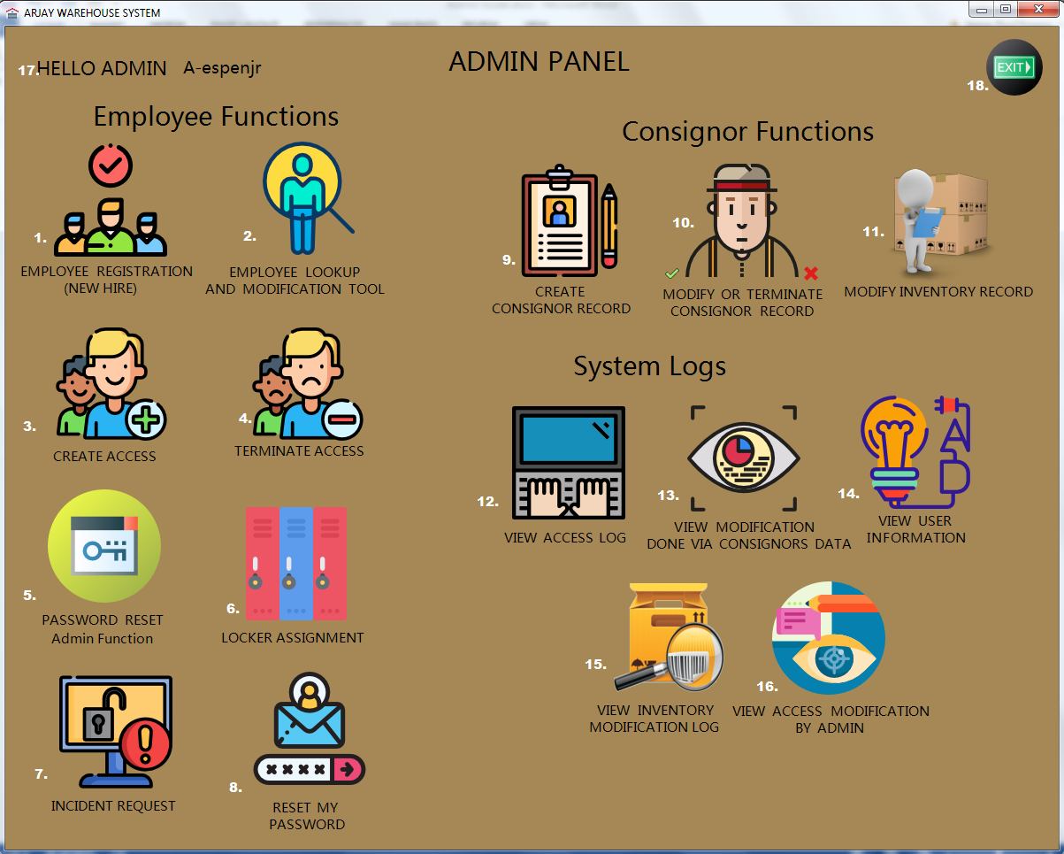

Here are the list of the functions available:

1. Employee Registration – Used to register a new or existing employee (for access purposes).
2. Employee Lookup – This function is being used to search for an employee record, update or even delete employee’s profile.
3. Create Access – Use to create an access to this system (applicable for Admin, Dispatch and Receiving).
4. Terminate Access – Function needed to terminate an access (applicable for Admin, Dispatch and Receiving).
5. Password Reset Admin Function - Function needed to manually reset employee’s password (applicable for Admin, Dispatch and Receiving).
6. Locker Assignment – Use this feature to assign a locker to certain employees.
7. Incident Request – Feature needed to view, modify and resolved incident or correction request.
8. Reset my password – Self-help feature to reset Administrators own password.
9. Create Consignors Record – Used to create consignors profile or data.
10. Modify or Terminate Consignors record – Feature needed to either update or terminate consignors’ record.
11. Modify Inventory Record – Use to modify inventory record submitted or requested by either receiving or dispatch department.
12. View Access Log – Feature to view all access made using this system (for both entry and exit).
13. View Modification done via Consignors data – This function can be used to track or identify the changes made onto a consignor’s data.
14. View Users Information – Use to view all the employees who do have access to “Arjay Warehouse System” (all applicable for all user type Admin, Dispatch and receiving).
15. View Inventory Modification Log – Form required to view system generated process done by an Administrator via client or consignors Inventory record.
16. View Access Modification by Admin – Feature needed to view changes and actions done by an Administrator (via employee level).
17. Greeting message and the user id of the person who is currently logged in.
18. Exit button - Can be used to terminate the session.

4.1. Employee Registration

1. Used this to register a new or existing employee, this is required in order for an administrator to create an access (applies for all three access role: admin, dispatch and receiving).

The administrator needs to click the button or icon as described below.

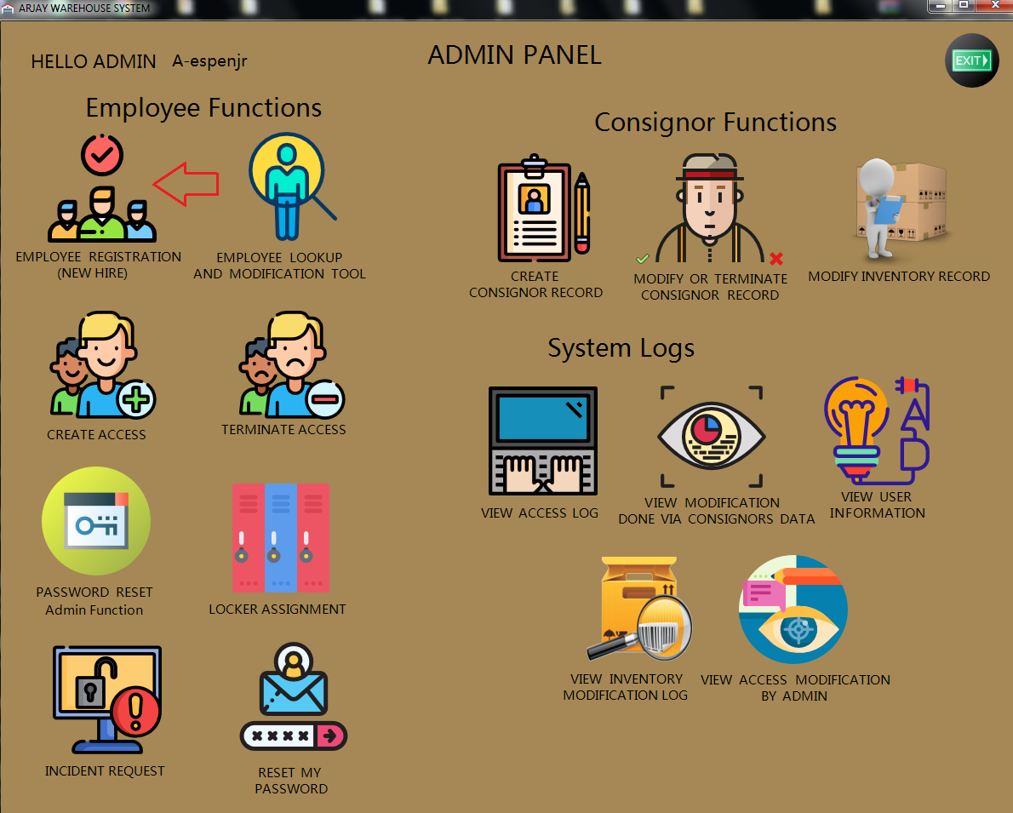

After clicking the Employee Registration button from the Admin Dashboard the employee registration form will appear.

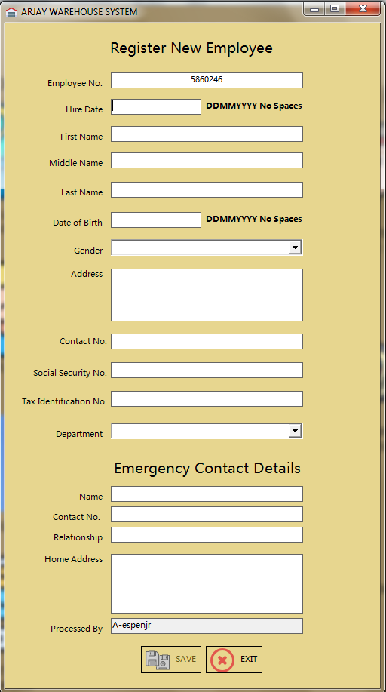

Note: Employee no. will be generated automatically when the main form or application loads and by default the save button will not go to an active state if there’s an empty field.

1. Once all the information is completely field up, that is the only time that save button will be set to active state or clickable.

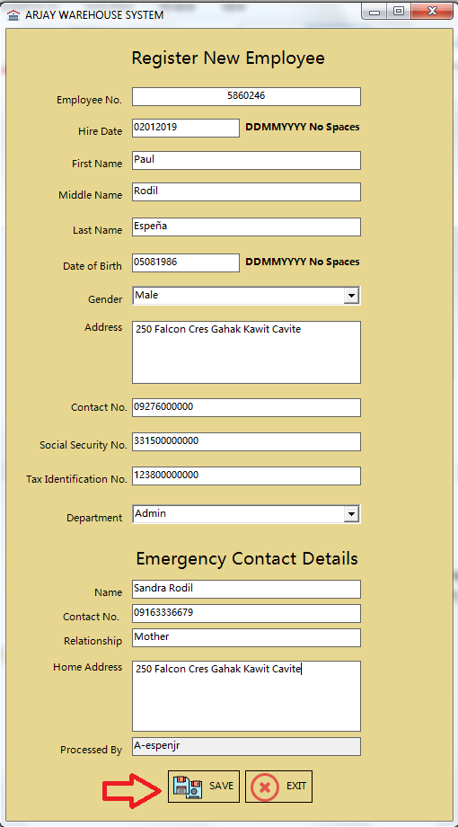

1. Successful message will be prompted once done.

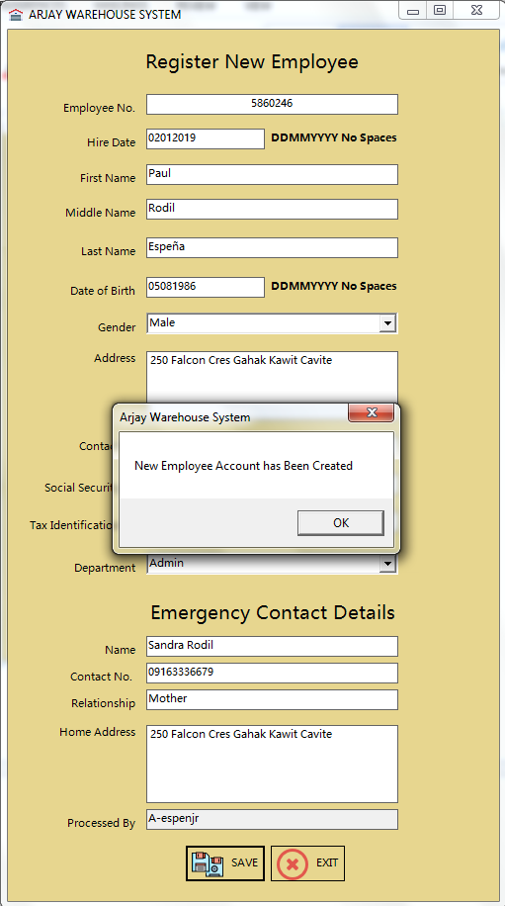

Note: After hitting the ok button system will going to clear all the fields listed in the form and Clicking exit button will close this form.

* 1. Employee Lookup

Used this to search, view, modify or update and delete employee’s information.

The administrator needs to click the button or icon as described below.

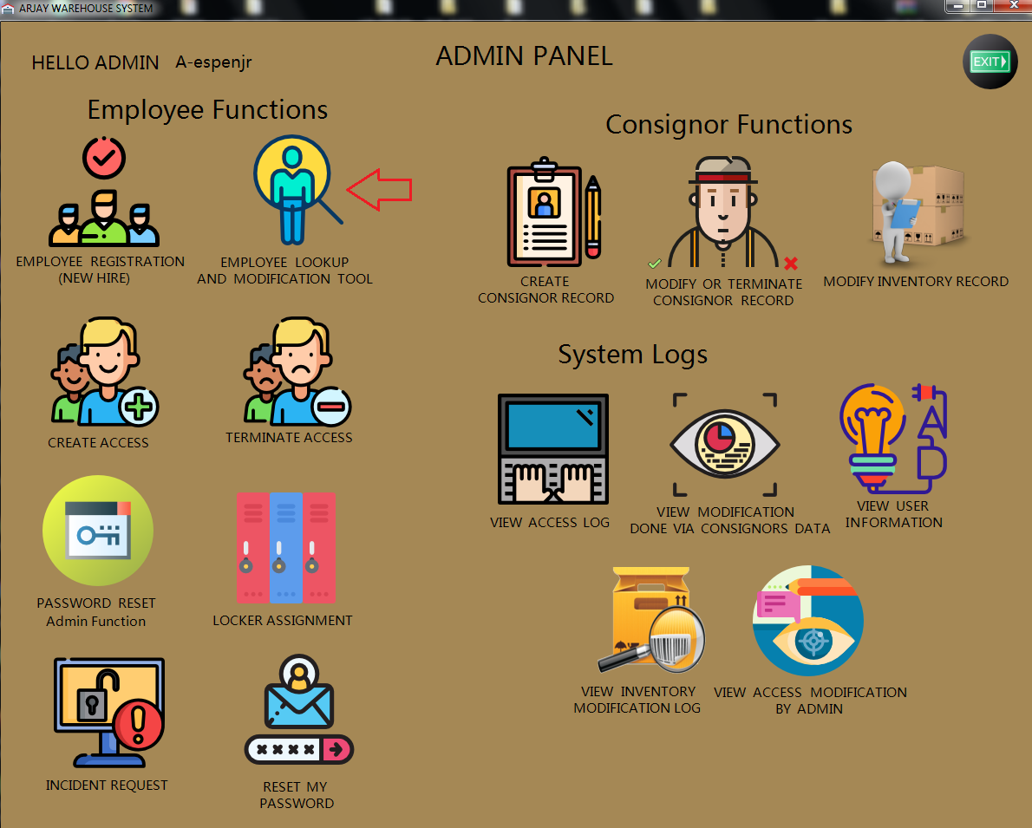

After clicking the Employee Lookup button from the Admin Dashboard the form will appear as described below.

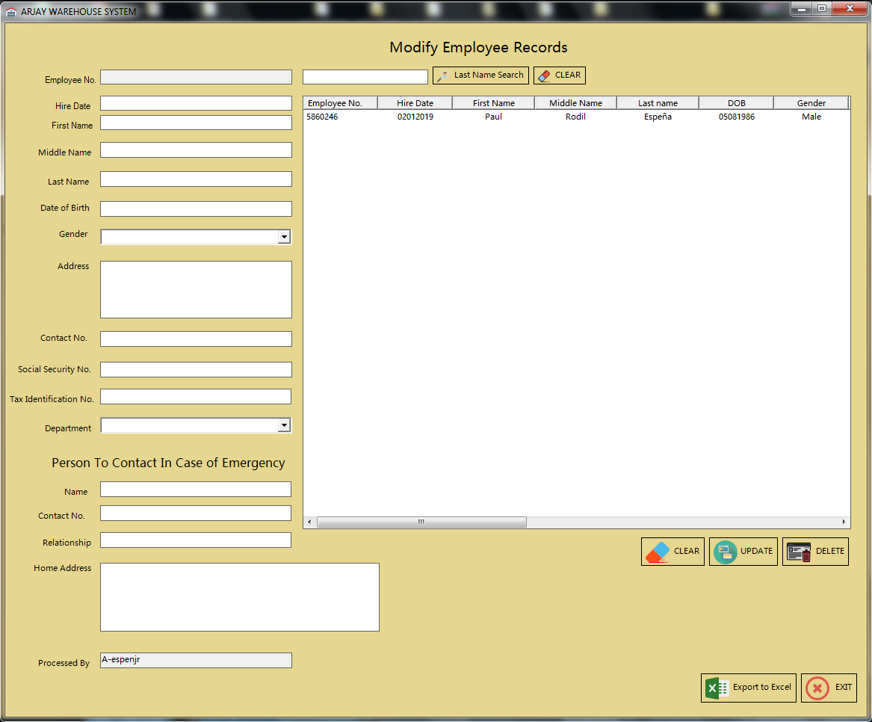

Note: Employee Lookup Form is being divided into multiple section and functions.

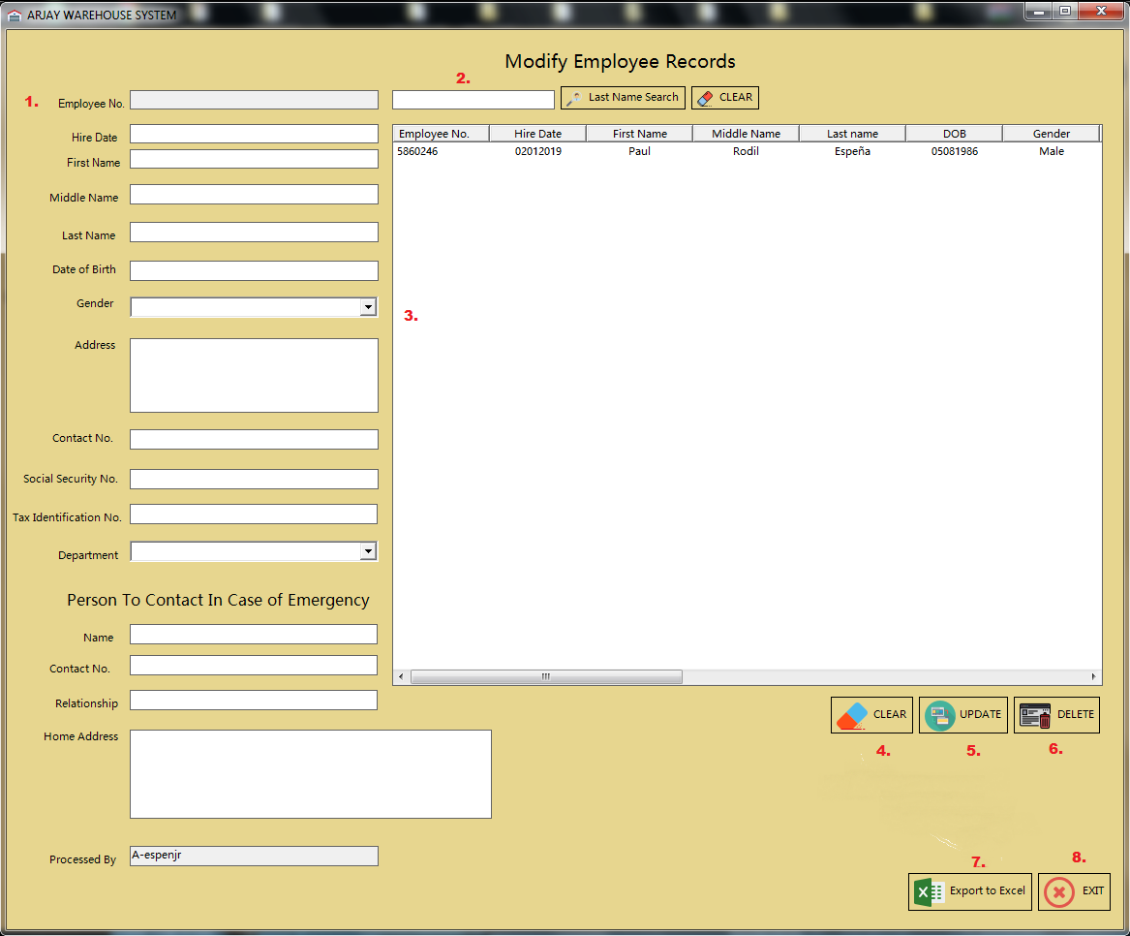

Here are the list of the sections associated with form:

1. Information panel – This is where the employee information will be displayed, this is applicable for edit and delete function.
2. Search function – Administrator can use this to search for an employee using the employee’s last name.
3. List view panel – This will display all the employee information that the administrator created (please see Employee Registration process).
4. Clear Button – This button will going to clear all the information present via Information panel.
5. Update Button - This button will save the changes made once the administrator made some changes to an employee’s data or profile.
6. Export button – This function will export all the data listed in the list view panel all the way to an excel spreadsheet (excel application is required).Using this function it will be easier for the administrator to filter the searches and can also be used for auditing and reporting purposes.
7. Exit button – Button used to exit this form.

Note: All changes that will be made using Employee lookup form will be log automatically. And administrators logon ID will be fetch for security and auditing purposes.

In order for the data to show up or to be listed onto the Information panel, the user or administrator need to click the data listed via list view panel or section. Once the data is placed or posted that is the best time to perform the necessary action required (as per description above).

Sample snapshot:

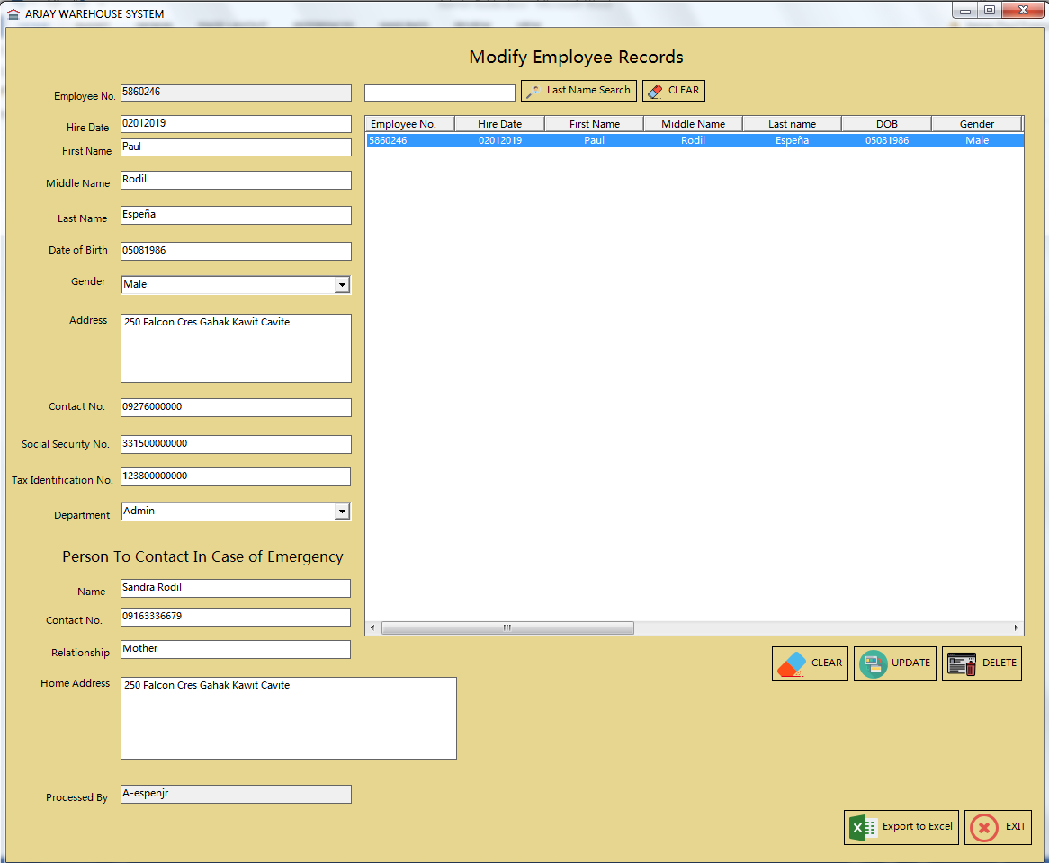

* 1. Create Access

Used this to create an access to this system “Arjay Warehouse System”. This procedure is applicable for all three access roles Admin, Dispatch and Receiving.

Reminder: To create an access please ensure that the employee is present to the employee’s database or record (Please see Employee Registration process).

The administrator needs to click the button or icon as described below.

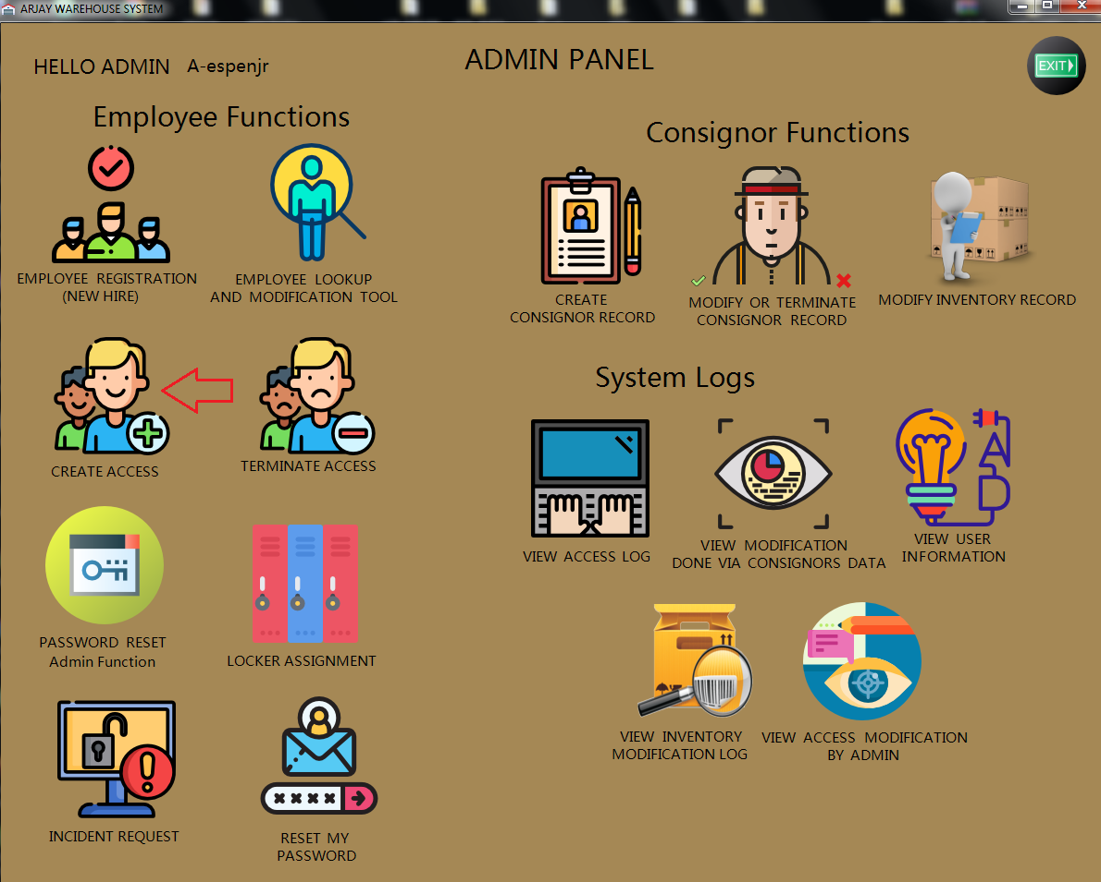

After clicking the Create Access button from the Admin Dashboard the create account panel will show up.

Snapshot of Create Account Panel:

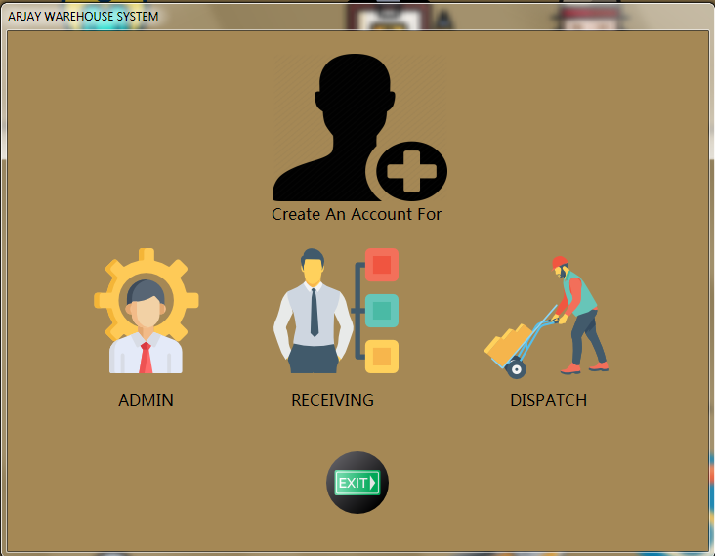

Administrator is required to choose the type of access that needs to be created.

Note: The procedure for all three roles are all the same as far as data and information is all concern.

After choosing or clicking the type of access needed the create access form will appear.

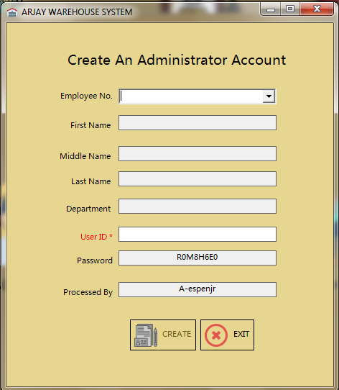

Administrator needs to click the drop-down arrow next to Employee No.

Reminder: The password is a system generated password and this form will generate it automatically and administrator cannot overwrite this field, manual reset is required if Administrator wanted to change this.

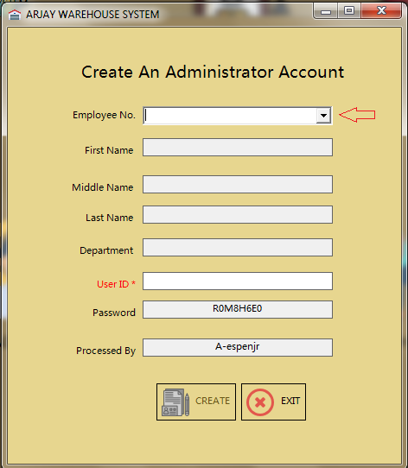

Snapshot after choosing the employees Employee No.

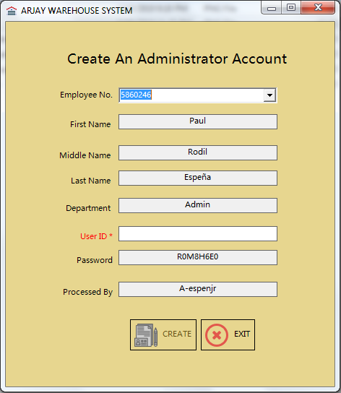

Note: The Administrator is required to enter the user ID depending on the company’s naming convention or user id format.

Snapshot once User ID has been entered:

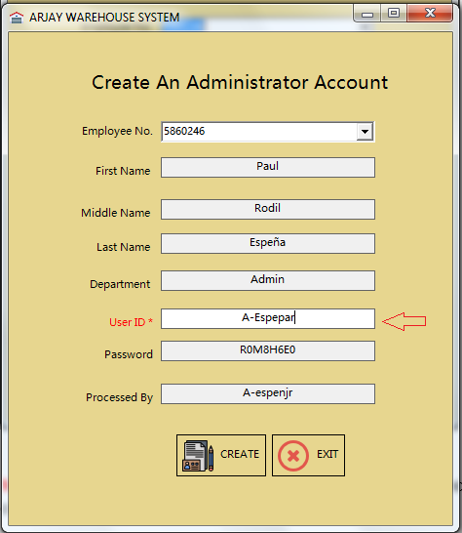

Reminder: The create button will not go to active state if there’s an empty field.

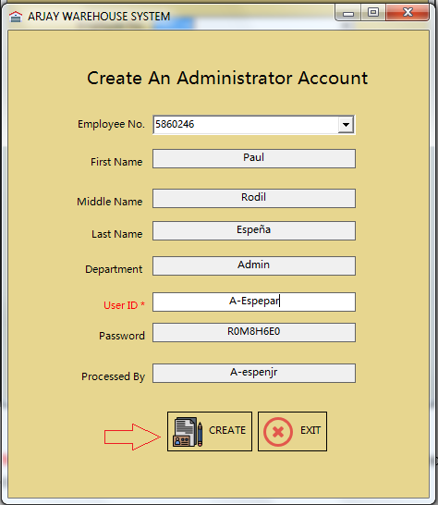

After clicking the create button a message prompt will appear notifying the Administrator that new access or account has been created.

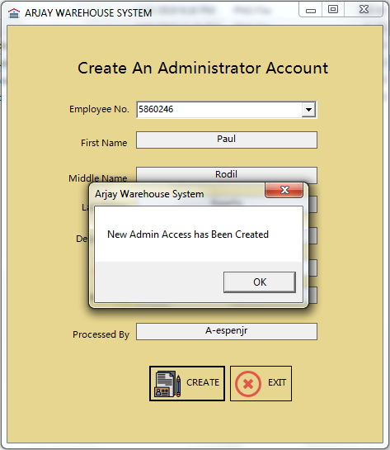

Click ok to go back to the form.

If the Administrator decided to click the Exit button then a confirmation message will appear.

By clicking the Yes button, system will redirect the Administrator back to Create Account Panel. If No then the Administrator will stay on the same page or form.

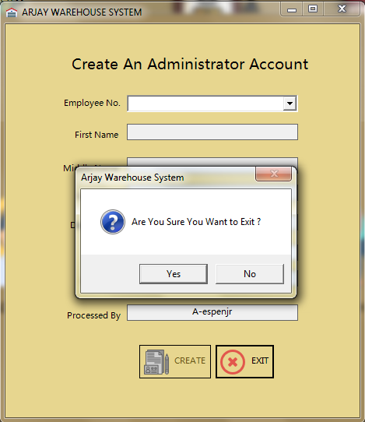

Note: This whole procedure is applicable for all three access roles. Admin, Dispatch and receiving. Form design may be difference from each other but process and data gathering are all the same.